QUIZ 2
- Descriptive analysis
- Descriptive Statistics for scale variables
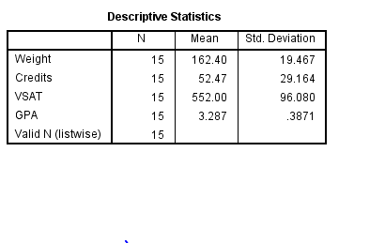
- Frequency tables for nominal variables.
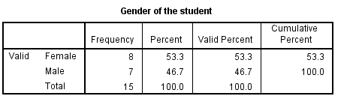
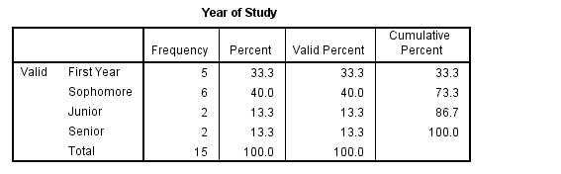
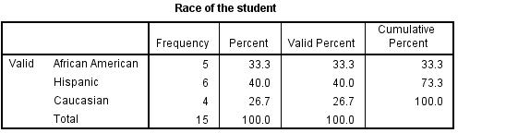

- Pie chart for college Year

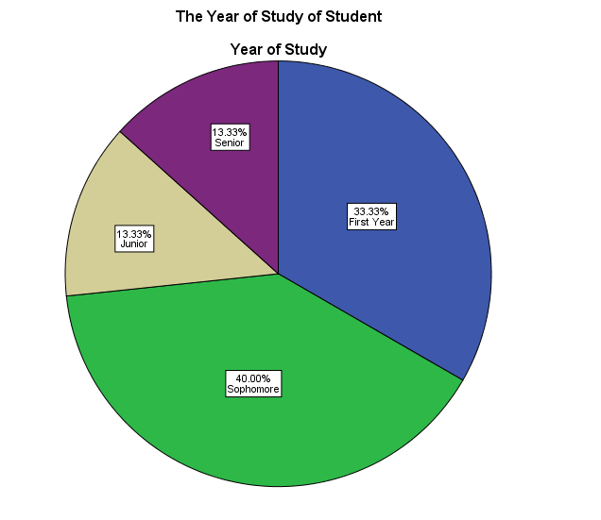

- Bar graph for men GPA for students in each race
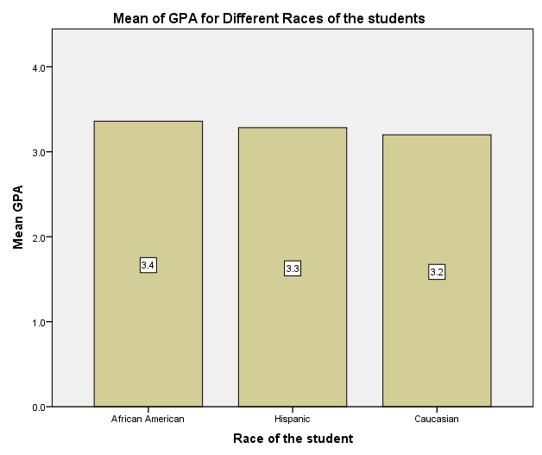

- Mean Weight by gender table
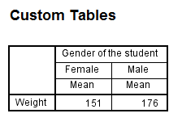
- The mean weight of males is 176
- The mean GPA of African American students is 3.4
5. VSAT versus GPA scatterplot for males only
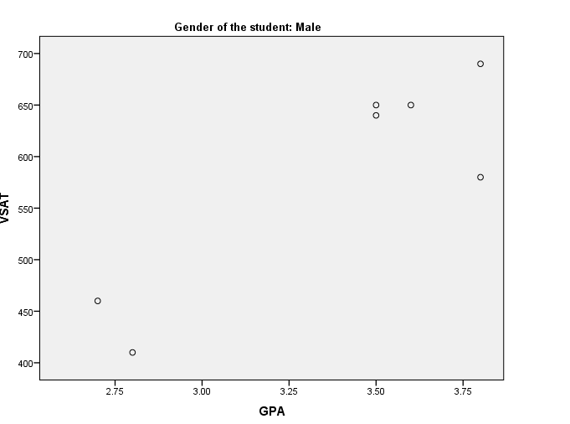
- The correlation between VSAT and GPA scores for males is 0.885.
